Comparing Deepfake Detection Between EffficientNet, ViTs and a CNN ViT Hybrid
Agustin Munoz, Leo Findley, Danny Kim

PROBLEM STATEMENT/INTRODUCTION
In recent years there has been an explosion in the usage of deepfake media where a video and/or sound recording can get digitally modified to recreate fake events, images or sounds. With the advancement of artificial intelligence models like Variational Autoencoders(VAEs) and Generative Adversarial Networks(GANs) deepfakes have become more accessible and accurate which results in media that is harder for the naked eye to distinguish as real or fake. Deepfakes are not inherently bad, they can be used in films to enhance or change an actor’s appearance, or just as a fun face swap app you use with your friends, but recently there have been reports of deepfakes being used to promote scams to people, create fake news and other malicious acts, with a trusted voice and face used to more easily deceive someone.
To combat the emergence of deepfakes there have also been great developments in the field of deepfake detection. When it comes to artificial intelligence models some of the most popular for deepfake detection are Convolutional Neural Networks(CNNs) and Visual Transformers(ViTs), D. Coccomini et al. on the paper Combining EfficientNet and Vision Transformers for Video Deepfake Detection propose a hybrid between these models that can match and sometimes even surpass the accuracy and efficiency of state of the art non-hybrid models all of this while using less parameters on the pretrained weights for the Efficient ViT hybrid[1].
One of the hybrid models proposed by D. Coccomini et al. uses EfficientNet as a feature extractor then after a linear projection of the extracted features it further processes the data with a Vision Transformer and a CLS token is used for producing the binary classification score of fake or real[1]. This is the model we will focus on for our deepfake video and audio detection comparison using EfficientNetB0 and a tiny ViT using a combined total of 9,364,822 trainable parameters, comparing it to a small EfficinetNetV2 with 22,151,822 trainable parameters and a small distilled ViT with 21,666,434 trainable parameters. For D. Coccomini et al. their results show similar accuracy and F1 scores to other state of the art models while using less parameters in the models they built.
If this hybrid model that uses less parameters for training is able to deliver on what it promises it can have a great effect on the field of deepfake detection. The ability to use smaller models to get similar results can have a positive impact on efficiency and speed due to the models needing to be trained for less time. It can also result in lower resource consumption as it will need to use less memory, less storage space and less energy making it more suitable to be deployed in environments with limited resources and hardware. This could lead to a lowering of costs for deepfake detection technology making it more widely available to use so that people can protect themselves against possible scams and misinformation attacks.
RELATED WORK
1. Evolution of Deepfake Datasets
The advancement of deepfake detection methodologies has been significantly propelled by the development of comprehensive datasets. These datasets are categorized into three generations each enhancing the complexity and realism of deepfake content.
First Generation: Datasets like DF-TIMIT, UADFV, and FaceForensics++ laid the groundwork by providing initial collections of manipulated media.[1] Second Generation: The Google Deepfake Detection Dataset and Celeb-DF introduced higher-quality forgeries, incorporating more sophisticated manipulation techniques.[1] Third Generation: Datasets such as the DeepFake Detection Challenge (DFDC) and DeepForensics presented large-scale, diverse, and challenging deepfake samples, facilitating the development of more robust detection models.[1] These datasets have been instrumental in training and evaluating deep learning models, contributing to the progressive improvement of detection accuracy and generalization capabilities.
2. Image and Video Deepfake Detection Techniques
Deepfake detection in images and videos has evolved through various methodologies. Such as behavioral analysis which are early detection methods focused on identifying unnatural physical or psychological behaviors[1] such as inconsistent eye blinking or head movements which are often challenging to replicate in deepfakes. There is also biological signal detection[1], which are techniques to detect subtle signals such as blood flow patterns that are often difficult to synthesize convincingly. Lastly visual artifacts[1] which would indicate that during the deepfake generation process blending errors or unnatural textures are introduced which form inconsistencies and visual artifacts.
3. Audio Deepfake Detection Approaches
The detection of audio deepfakes has garnered attention with the rise of sophisticated voice synthesis technologies. Some key approaches they use are spectrogram analysis[4] which by converting audio signals into spectrogram models can visualize frequency and temporal patterns which will help detect anomalies of synthetic audio. Deep learning models are then employed to capture spatial or temporal dependencies in audio data.
4. Multimodal Deepfake Detection
Lastly through our research we have seen that there are limitations of unimodal detection systems. Recent research has focused on multimodal approaches that integrate both visual and auditory information. By analyzing the coherence between audio and visual streams such as lip sync[5] consistency of speech patterns, these systems aim to detect discrepancies that may indicate deepfake content.

METHODOLOGIES
The performances of the CNN ViT and Hybrid models were assessed by applying the models on a database using real and deepfake videos and another database using real and deepfake audio.
For our video and audio task we compared a small EfficinetNetV2 against a small distilled ViT and a hybrid model using EfficientNetB0 as a feature extractor and a tiny distilled ViT, all using pretrained weights from the timm library[2]. These models were chosen as both the EffNetV2 and small ViT have approximately twenty two million trainable parameters while the combined tiny ViT and EffNetB0 use less than ten million parameters, which will let us test the theory of the hybrid model using less parameters than the other models while displaying similar results, all while letting us run the models with our limited time and resources as we couldn't run more complex models without sacrificing more time or crashing our environments.
These models were used on the Deep Fake Detection (DFD) Entire Original Dataset from Kaggle[3] for our video experiments, which features 3068 manipulated videos generated using the deepfakes and 364 original sequences, featuring 28 paid actors performing in 16 different scenes. For our main testing we used fifty randomly selected real and fake videos to process for our training and validation of the models. These videos then have some of their frames extracted and are labeled as real or fake, then the frames are split into a testing/validation split of eight to twenty and finally the frames are converted to a PIL image, resized to 224 by 224 and finally converted to a PyTorch Tensor.
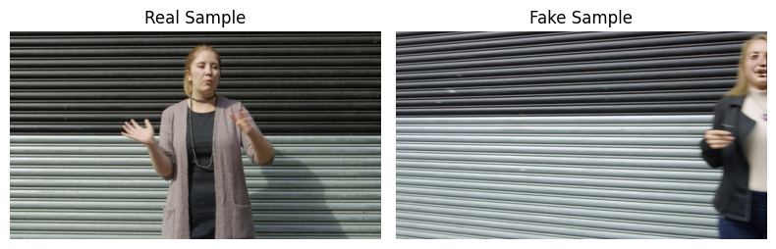

Figure 1: Real and Fake Video Frame Samples

To train each model, we used a consistent procedure to ensure fair comparison. The models were trained for ten epochs using the Adam optimizer with a learning rate of 0.0001 and a batch size of 32. Cross-Entropy loss was used as the objective function, as it is well-suited for binary classification tasks such as distinguishing real versus fake frames. During each training epoch, the model weights were updated through backpropagation using batches from the training set, and performance was evaluated on a separate validation set. Key performance metrics including training loss, validation accuracy, and F1 score were recorded after each epoch to track model convergence and generalization.
The audio models utilized a dataset consisting of around ~69,000 audio files that were 1-2 seconds long from Kaggle The Fake or Real Dataset[6]. The data was made so that classifiers are able to train for synthetic audios. “The dataset aggregates data from the latest TTS solutions (such as Deep Voice 3 and Google Wavenet TTS) as well as a variety of real human speech, including the Arctic Dataset (http://festvox.org/cmu_arctic/), LJSpeech Dataset (https://keithito.com/LJ-Speech-Dataset/), VoxForge Dataset (http://www.voxforge.org) and our own speech recordings.”[6] The .wav files were loaded using torchaudio and then converted to mono, then they were converted to 128-band mel-spectrograms. Afterwards they were converted to dB scale and then resized to 224x224 and normalized for our models to easily train on.
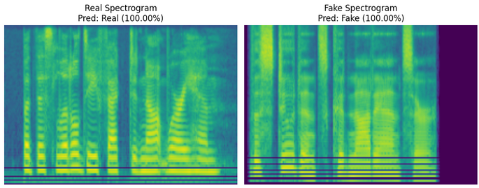

Figure 3: Real and Fake Audio Spectrogram Samples

For the Audio Model training we trained for five epochs using the Adam optimizer with a learning rate of 0.0005 ,Cross-Entropy for the loss function for its use in binary classification and a batch size of sixteen. The metrics gathered during the model training and validation were training and validation loss and training and validation accuracy and then we plot a confusion matrix of the models.

EVALUATION
- Video Models Experiments
The video models were evaluated on loss, accuracy and F1 score using cross entropy loss.
The Deep Fake Detection (DFD) Entire Original Dataset was split 80-20 into training-validation sets with a batch size of thirty two. Fifty real and fifty fake videos were selected to have their frames extracted and used for training/validation where our models ran for ten epochs each using the Adam weights optimizer.
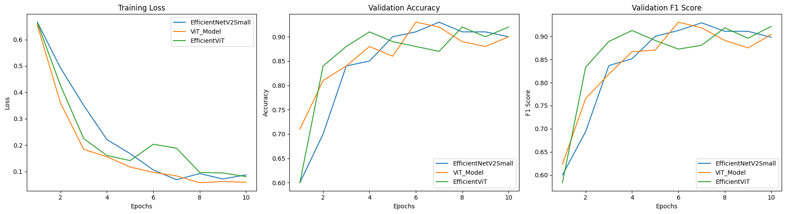
Figure 2: EfficientNetV2 Vs. ViT Vs. Hybrid model in loss, accuracy and F1 scores
Figure 2 shows all three models receiving fairly similar evaluation scores, where the hybrid gets marginally better accuracy and F1 scores on validation and the ViT gets a marginally better loss. These scores reflect the results of the paper by D. Coccomini et al. where the hybrid model performs similarly to state of the art models while using far less pretrained weights. The results are better shown in the DeepfakeVideoDetectionPretrained50/50 notebook in our zipped folder where you can better see the scores per epoch.
- Audio Models Experiments
For our Audio Models the spectrograms are run through the CNN and Vit models for 5 epochs while using the same evaluations used in the video experiments. The results are very similar in efficiency and using hybrid models rather than individually showed major improvements. Performance-wise, EfficientNet CNN handled audio poorly due to its focus on local features using small convolution kernels. It is good for textures and patterns but misses global structure or subtle temporal inconsistencies. Fake spectrograms often have subtle or long range artifacts that CNNs don’t naturally attend to. Vits on the other hand learns global relationships and performs better at spotting distributed irregularities such as unnatural transitions, and harmonic mismatches.
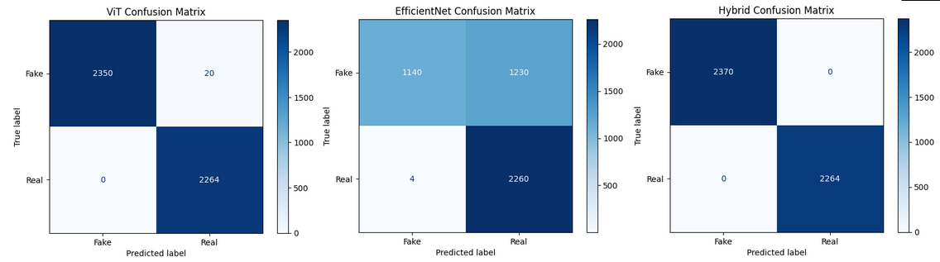
Figure 4: ViT, EfficientNet and Hybrid Model Audio Confusion Matrix
The confusion matrix indicates the ground floor of performance of the individual models, but as you can see the hybrid model shows that combining them created an even better result in efficiency and performance. The hybrid model utilized EfficientNet-B0 backbone with 1290-dim features and ViT tiny with 192 dim features and for the fusion head we concatenated the features to learn optimal combinations as a good baseline and as well as preserving all features to retain the full representational power of both models.

CONCLUSION
Our experiments demonstrated that hybrid models combining Convolutional Neural Networks (CNNs) with Vision Transformers (ViTs) can deliver competitive results in deepfake detection while maintaining a lower parameter count and resource footprint. In the video-based detection tasks, all three models, EfficientNetV2, ViT, and the hybrid, performed similarly in terms of loss, accuracy, and F1 score. However, the hybrid model slightly outperformed the others in accuracy and F1 score while using fewer trainable parameters, reinforcing the findings from Coccomini[1] that hybrid architectures can achieve state of the art performance efficiently.
In the audio detection experiments, the differences between models became more pronounced. The ViT-based models consistently outperformed their CNN counterparts. This performance gap is attributed to the ViT’s ability to capture long-range dependencies and global structure in spectrograms, subtle temporal patterns, and distributed artifacts that CNNs often miss due to their localized receptive fields. CNNs excel at detecting fine grained textures, but this focus limits their effectiveness when global coherence or transitions are critical, such as in synthetic speech. The hybrid model, which fused EfficientNet-B0 features with ViT embeddings, was able to balance both local detail and global context, achieving the highest performance overall on the audio tasks.
Together, these results suggest that hybrid ViT-CNN models are a promising direction for deepfake detection, especially in resource-constrained environments. Their ability to offer high accuracy with fewer parameters makes them suitable for both large scale and lightweight deployment scenarios. The ViT’s strength in audio tasks also points to the importance of modeling global relationships in synthetic media, which can be crucial for detecting subtle changes as deepfakes improve in quality.

CONTRIBUTIONS
Agustin Munoz: Video models development and testing, as well as a bit of help for the audio models
Danny Kim: Audio models development and testing
Leo Findley: Video models development and testing

REFERENCES
[1]Davide Coccomini, N. Messina, C. Gennaro, and Fabrizio Falchi, “Combining EfficientNet and Vision Transformers for Video Deepfake Detection,” Lecture Notes in Computer Science, pp. 219–229, Jul. 2021, doi: https://doi.org/10.1007/978-3-031-06433-3_19.
[2] R. Wightman, PyTorch Image Models (timm), GitHub repository, https://github.com/huggingface/pytorch-image-models, accessed April 20, 2025.
[3]Sanika Tiwarekar, “Deep Fake Detection (DFD) Entire Original Dataset,” Kaggle.com, 2024. https://www.kaggle.com/datasets/sanikatiwarekar/deep-fake-detection-dfd-entire-original-dataset
[4]Lam Pham1∗, Phat Lam2∗, Truong Nguyen3, Huyen Nguyen4, Alexander Schindler5 “Deepfake Audio Detection Using Spectrogram-based Feature
and Ensemble of Deep Learning Models”
https://arxiv.org/pdf/2407.01777
[5]Aaditya Kharel 1, Manas Paranjape 1, Aniket Bera 1 “DF-TransFusion: Multimodal Deepfake Detection via Lip-Audio Cross-Attention and Facial Self-Attention”
https://arxiv.org/pdf/2309.06511
[6]The Fake-or-Real (FoR) dataset
https://www.kaggle.com/datasets/mohammedabdeldayem/the-fake-or-real-dataset

